**List various network cable, also write short description.**

**1.Coaxial Cable**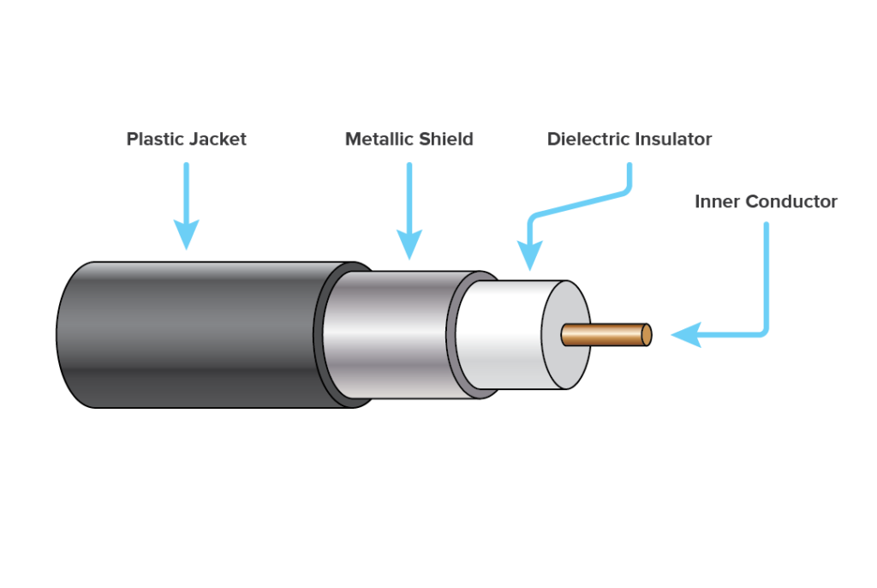

**Definition**:  
Coaxial cable is a type of electrical cable consisting of a central **core conductor** (usually copper), surrounded by an **insulating layer**, a **metallic shield** (to block interference), and an **outer protective jacket**.

**Key Features**:

* **Shielded design**: Reduces signal interference.
* **Durable**: Suitable for outdoor and long-distance use.
* **High bandwidth**: Can carry large amounts of data.

**Uses**:

* Cable TV connections
* Internet services (broadband)
* Early Ethernet (10BASE2, 10BASE5)
* CCTV and security systems

**Examples**:

* **RG-6**: Common for cable TV and internet.
* **RG-59**: Used for CCTV and short-distance video.

**2. Unshielded Twisted Pair (UTP)** 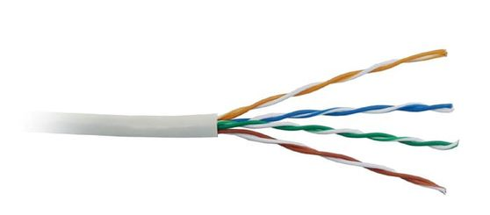

**Description**:  
A cable with pairs of wires twisted together to reduce interference. Lacks additional shielding.

**Used in**:  
LAN (Ethernet), telephone lines, modern networking.

**Example**:

* Cat5 – up to 100 Mbps
* Cat5e – up to 1 Gbps
* Cat6 – up to 10 Gbps over short distances
* Cat6a/Cat7 – better shielding and higher speeds

**3. Shielded Twisted Pair (STP)**

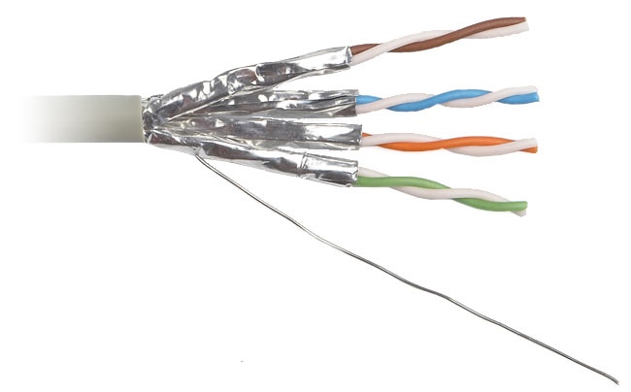

**Description**:  
Similar to UTP but includes foil or braided shielding to reduce electromagnetic interference.

**Used in**:  
High-interference areas like factories or hospitals.

**Benefit**:  
Provides better noise immunity than UTP.

**4. Fiber Optic Cable**

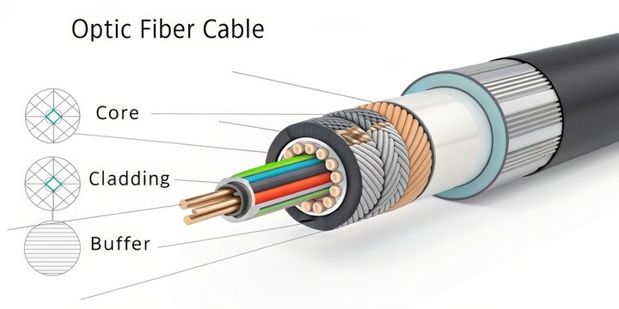

**Definition**:  
A **Fiber Optic Cable** is a type of network cable that transmits data using **light signals** through **glass or plastic fibers**, instead of electrical signals over copper wires.

**🔍 Key Features:**

* **High Speed**: Supports very high data transfer rates (up to Tbps).
* **Long Distance**: Can transmit signals over **kilometers** without signal loss.
* **Immune to Electromagnetic Interference (EMI)**: Ideal for environments with high interference.
* **Thin and Lightweight**: Fibers are thinner and more flexible than copper cables.

**📌 Applications:**

* Internet backbone and broadband networks
* High-speed LAN connections
* Cable TV transmission
* Medical imaging and military communications

**Different between guided and unguided media.**

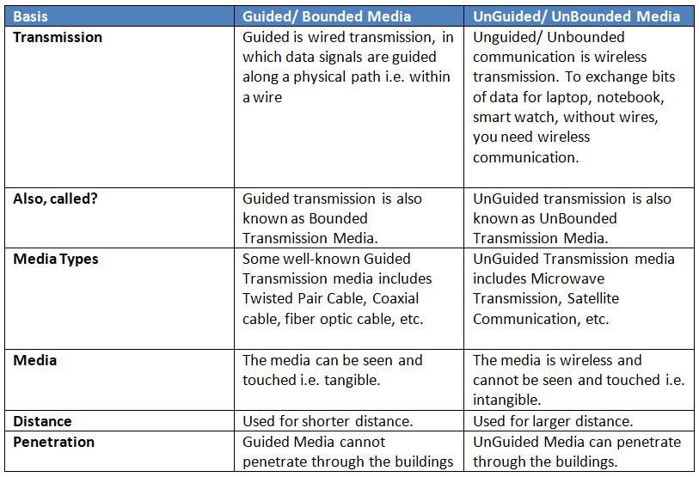

**Give cross wire cable and straight cable diagram (colour coded wise).**

A. straight cable:

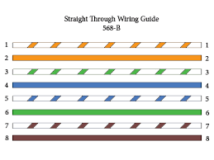

B. cross wire:

